Lab 2.2: Deploy files to Bitbucket via Git

This section will guide you to:
- Install Git and set up your account in Bitbucket.
- Execute the popular commands in Git.
- Push all the files from local repository to Bitbucket.
Step 2.2.1 : Set up your Bitbucket account.
Go to https://bitbucket.org/account/signup/ , enter the required details, and click on Agree on sign up.
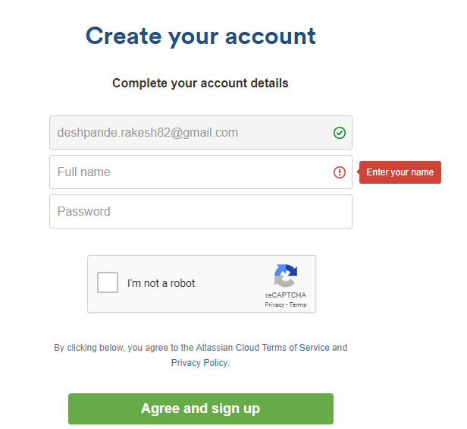
Verify your account credibility by confirming from your email ID. After the setup, you will be redirected to the below page
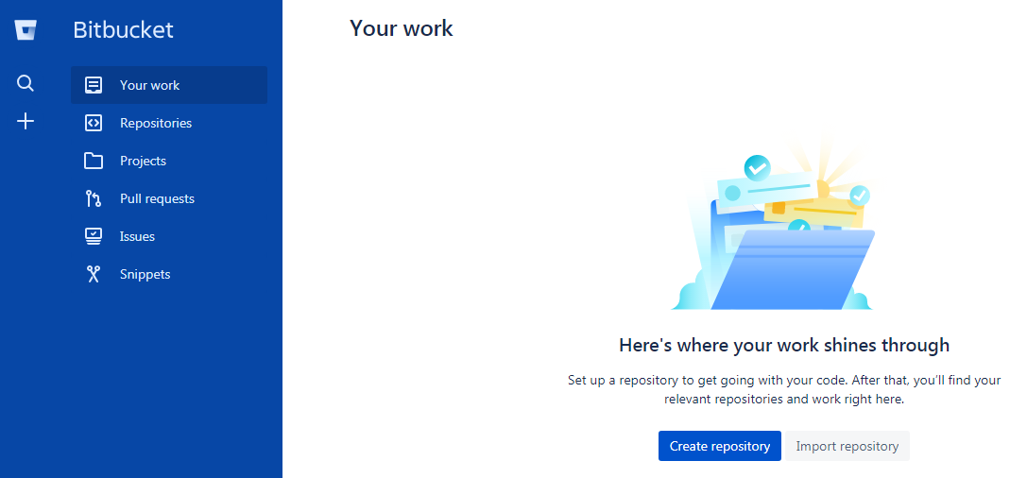
Click on Create repository and enter the repository name “Lesson—02—GitFiles” and uncheck the Access level (Let the files be public). Version Control should be Git. Do not make changes in Advanced settings. Click on Create repository.
You will be redirected to the below page
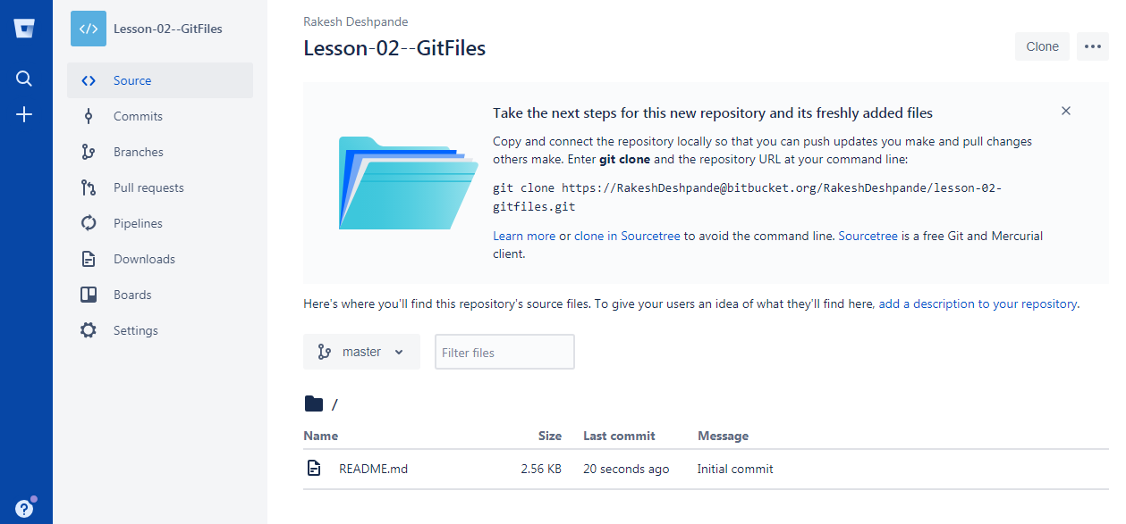

Step 2.2.2 : Create multiple files and content in each file.
To create multiple files with different extensions and to create a folder to store all the files in one place. Follow the below steps:
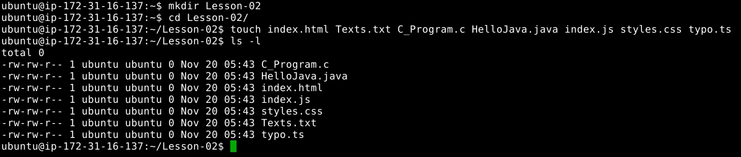
You can use any of the text editors available in Linux, but prefer vi editor. To open the vi in editor mode, follow the step shown below. You can execute the same command for any file extension you have created in the above step.
Execute the below command in the vi editor to save and return to the terminal.
Esc + [shift]:wq
Add the below code in C_Program.c file.
#include<stdio.h>
int main(){
printf(“Hello! I am C-Program. Thank you!”);
return 0;
}

Add the below code in HelloJava.java file.
class HelloJava {
public static void main(String args[]){
System.out.Println(“ I am your Java Program. Thank you! ”);
}
}

Add the below code in index.html file.
<html>
<head><title>HTML</title></head>
<body>
<p> I am your HTML Page. Thank you! </p>
</body>
</html>
Add the below code in index.js file.
var texts = “I am your JavaScript Program”;
console.log(texts);

Styles.css, Texts.txt, and typo.ts files will not contain any codes or statements.
Step 2.2.3 : Initialize Git.
Since all the files are to be pushed, initialize a .git folder inside the directory by executing the below commands.
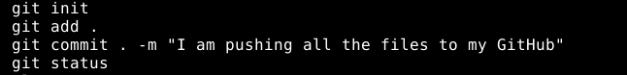
Please follow the below process for step-by-step confirmation of each command execution.
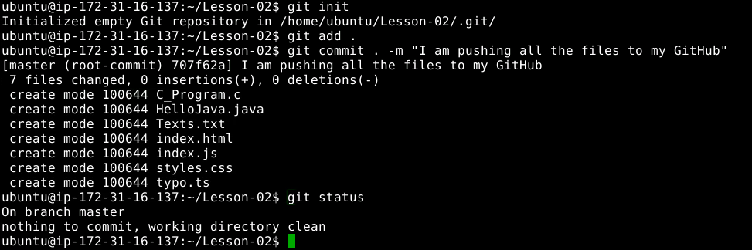
Step 2.2.4 : Add SSH Keys to Bitbucket.
Switch the current directory to ssh by executing below command.
cd ~/.ssh
Generate an RSA key for the registered email Id.(An example is available below)
ssh key-gen -t rsa -C “rakesh.deshpande@simplilearn.net”
gedit id_rsa.pub

Copy the entire key from the clipboard. Choose Your avatar > Bitbucket settings > SSH Keys and click on Add key and paste the key and save it.
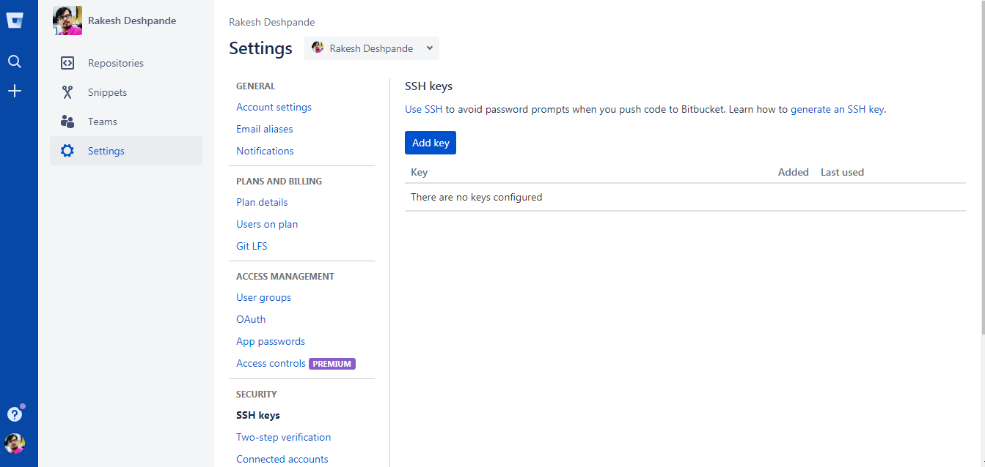
In the terminal, execute ssh-add to save the key and link it with local git.
Step 2.2.5 : Push the files to Bitbucket.
Click on Clone available on the top right side of the repository and select SSH from the dropdown.
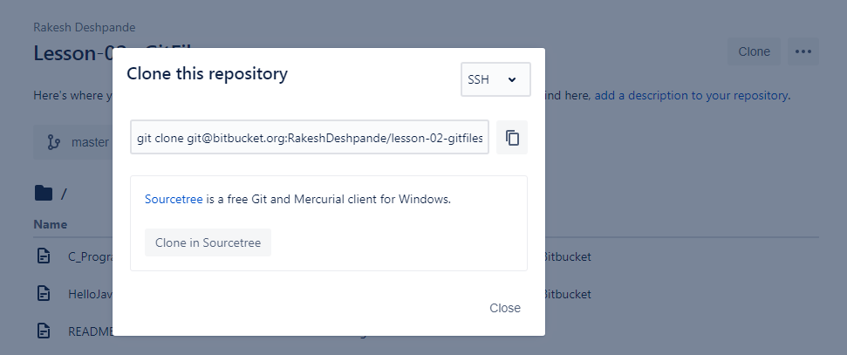
Clone the folder from Bitbucket to your local disk by executing the below command.
git clone git@bitbucket.org:<YourRepositoryLink>.git
Add the files to cloned folder and initialize Git.
Since all the files are to be pushed, initialize a .git folder inside the directory by executing the below commands.
Please follow the below process for step-by-step confirmation of each command execution.
now push all the files to Bitbucket by executing the below command.
git push origin master
Reload your Bitbucket account to confirm the output shown below.
